**Members:** Marcus Leocario

Joachim Arguelles

**Github Link:** <https://github.com/dummy-ie/GDGRAP1-MP>

**Implementation Summary**

| **Feature** | **Summary** |
| --- | --- |
| 3D Models | The loading of 3D models was implemented through a class that would receive a string of the file path to the .obj file, alongside file paths for a texture and/or normal map texture if needed. |
| Skybox | The skybox was created in Main.cpp. Textures taken from <https://www.pngwing.com/en/free-png-hzcii>. |
| Lighting | The Light class is implemented as a pure virtual class, while DirectionLight and PointLight inherit from Light. |
| Cameras | Similar to the lights, the Camera class is pure virtual, while the OrthoCamera and PerspectiveCamera inherit from it. |
| Player Controls | Using GLFW’s input callback listener functions which connect to Key_Callback( … ) and Cursor_Position_Callback( … ) located in Main.cpp. |
| OOP | Classes are located in their respective folders, with classes made for 3D Models, Lighting, Cameras, Shaders, and the Player object. |

**Game Map**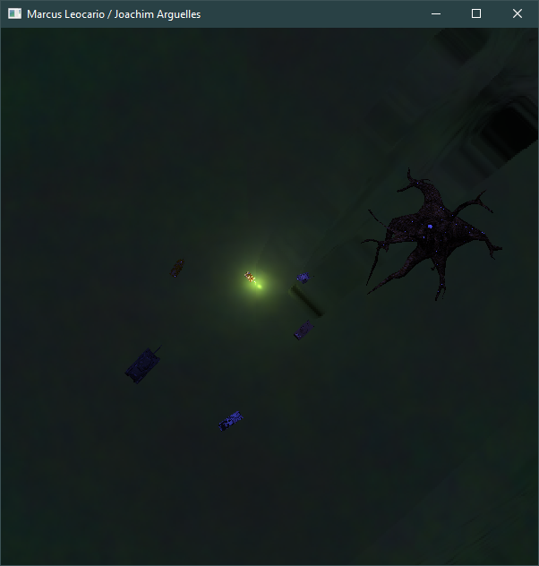

**Pictured above: The game seen from the top orthographic camera. Objects on the map are labeled.**

**Models**

* **Player Model (Tiger I) from** <https://free3d.com/3d-model/german-wwii-era-heavy-tank-tiger-i-254401.html>
  + 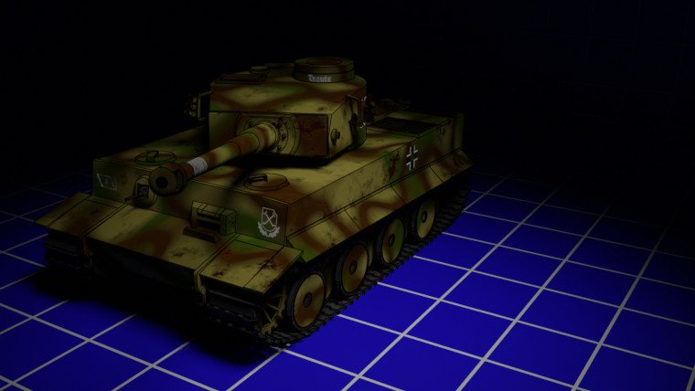
* **Fictional tank from** <https://www.turbosquid.com/3d-models/fictional-pbr-tank-3d-model-1382107>
  + 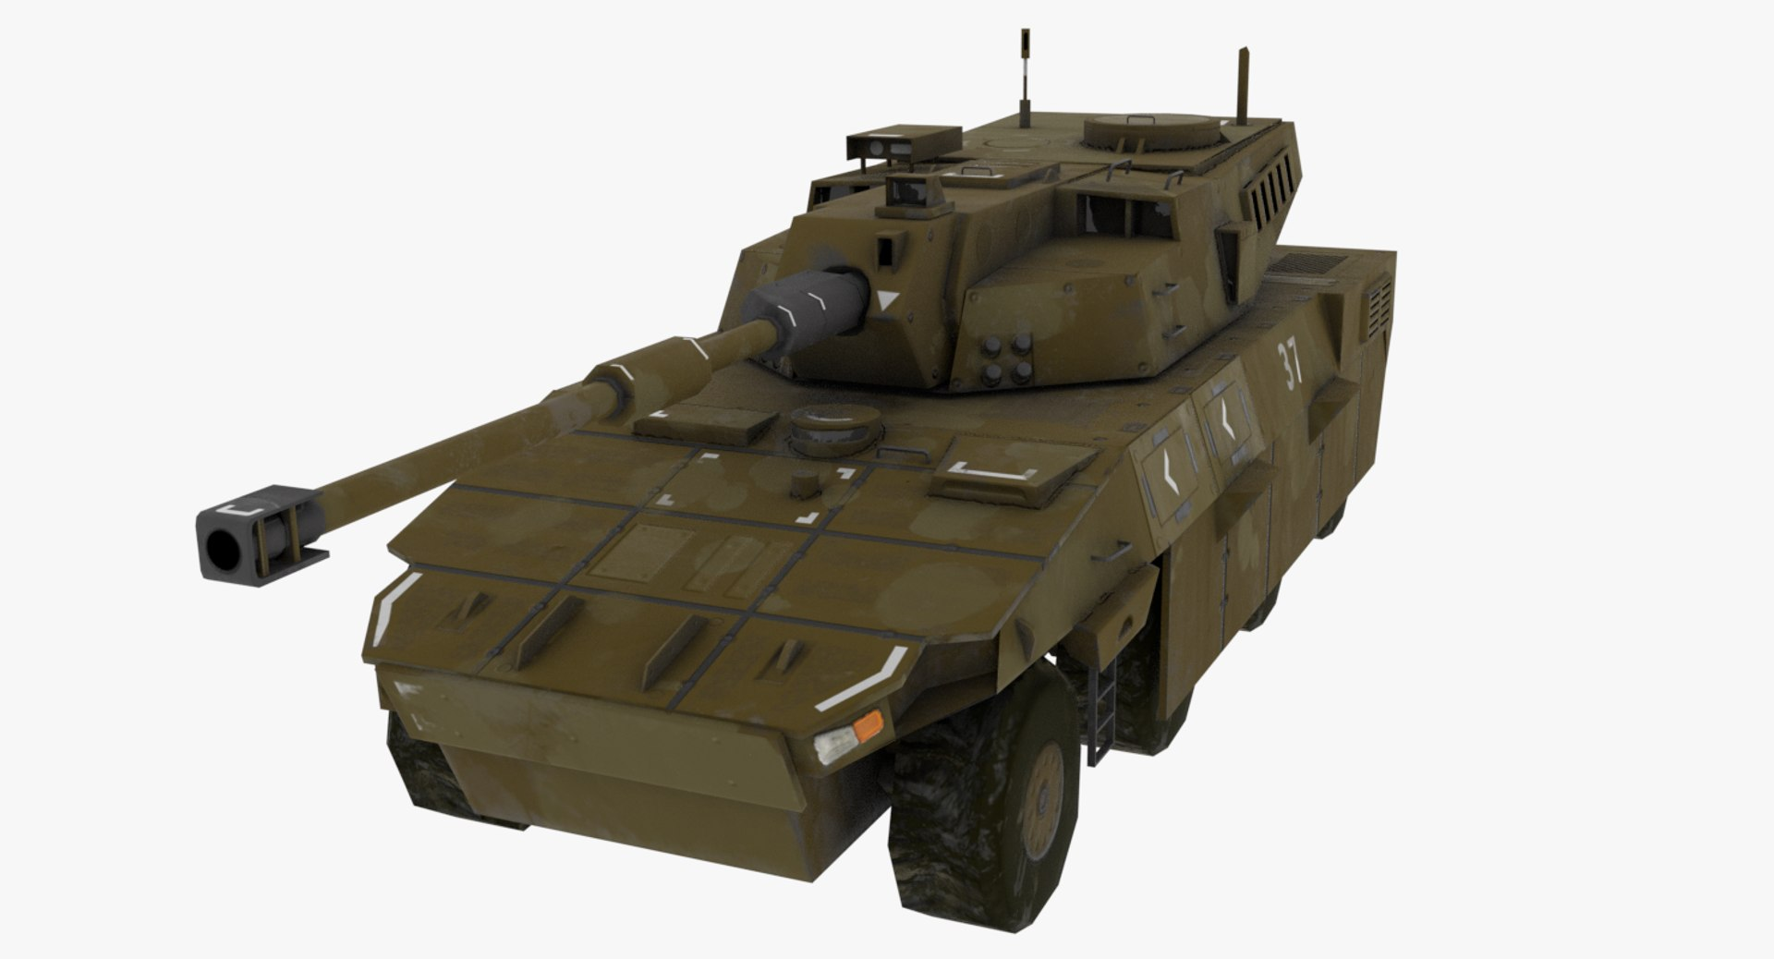
* **Tank from** <https://www.turbosquid.com/3d-models/3d-model-of-tank/899695>
  + 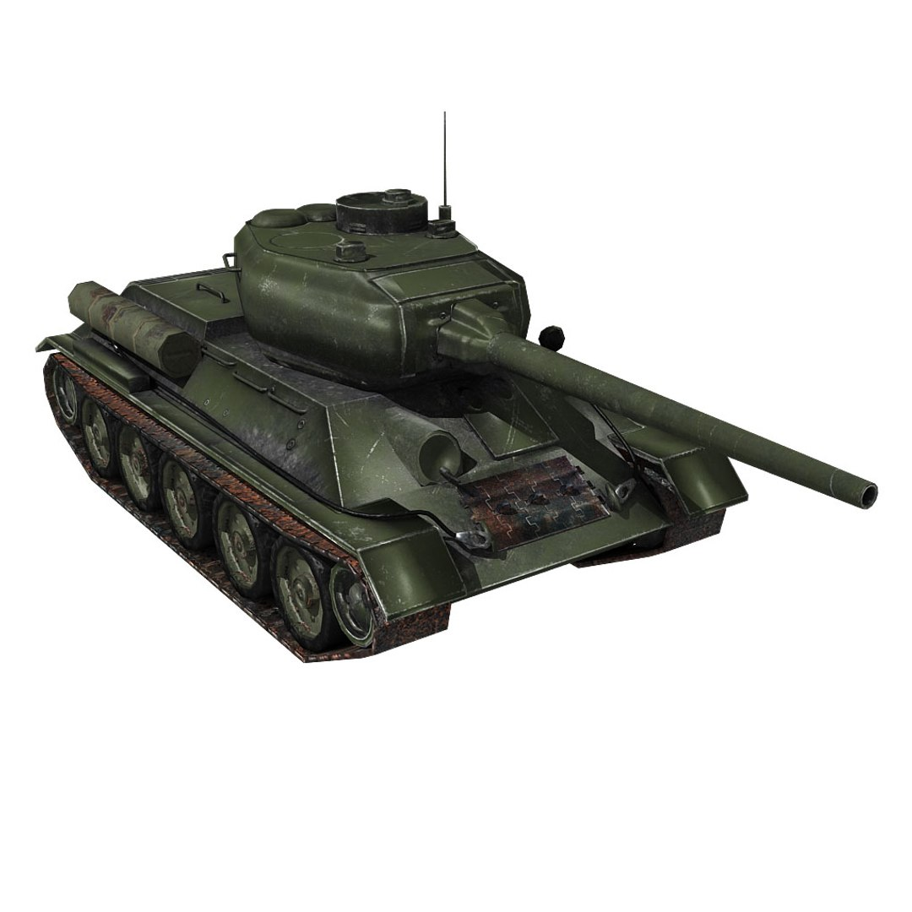
* **Ozelot from** <https://www.turbosquid.com/3d-models/free-3ds-mode-wiesel-2-ozelot-anti-air/361920>
  + 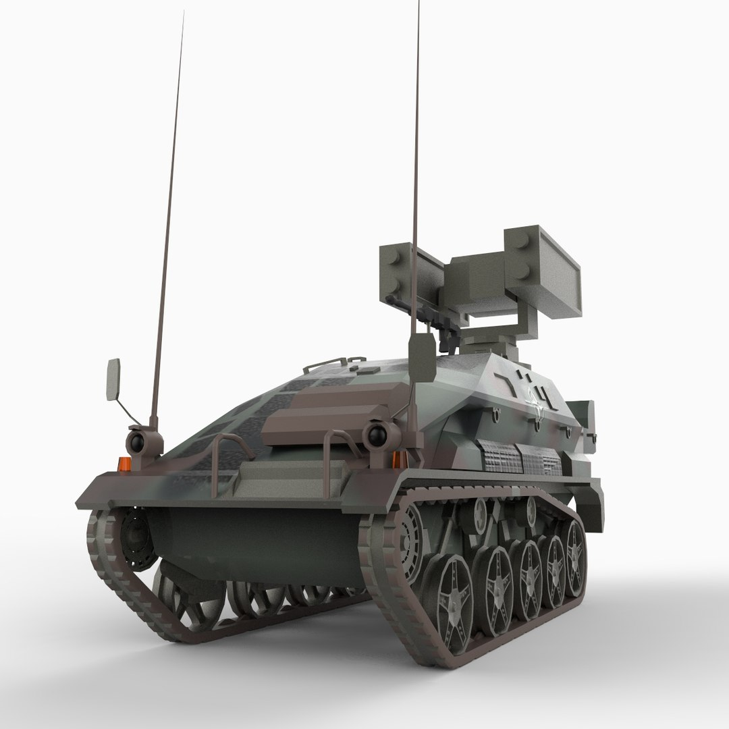
* **Sherman from** <https://www.turbosquid.com/3d-models/free-sherman-3d-model/949824>
  + 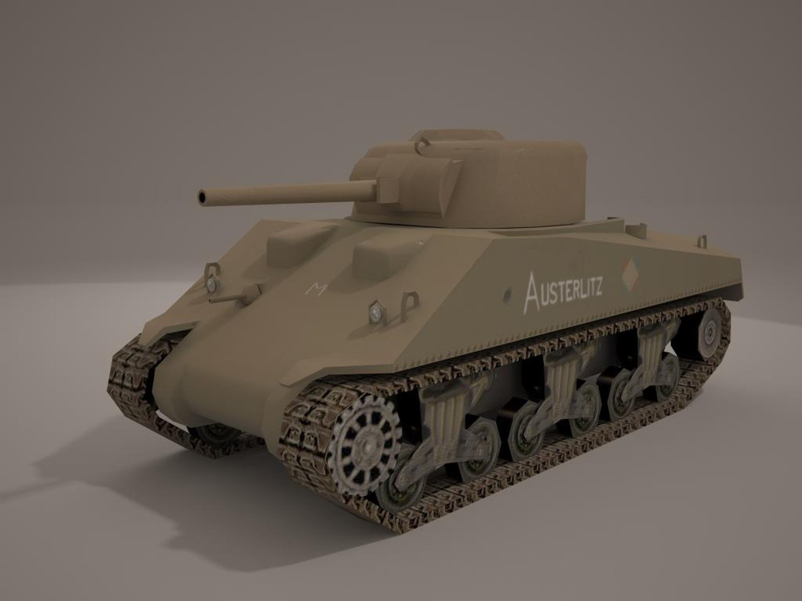
* **T90 from** <https://free3d.com/3d-model/t-90a-russian-tank-47395.html>
  + 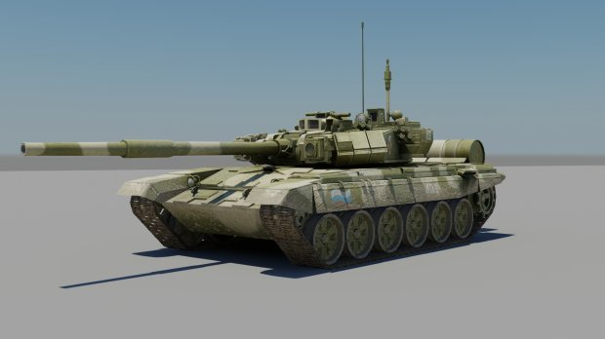
* **Dead Tree from** [**https://skfb.ly/orGPV**](https://skfb.ly/orGPV)
  + 